1. Get all students from class A

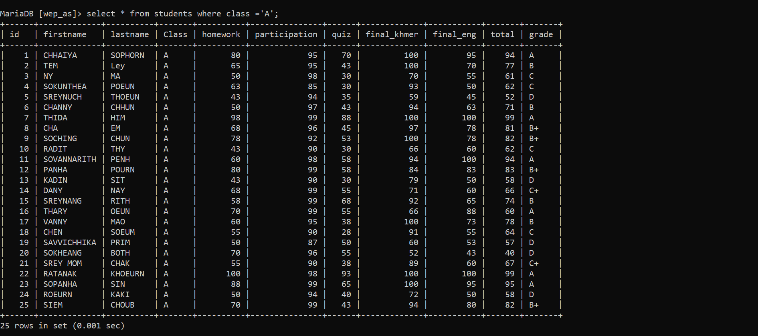

1. Get all students who failed quiz in class C

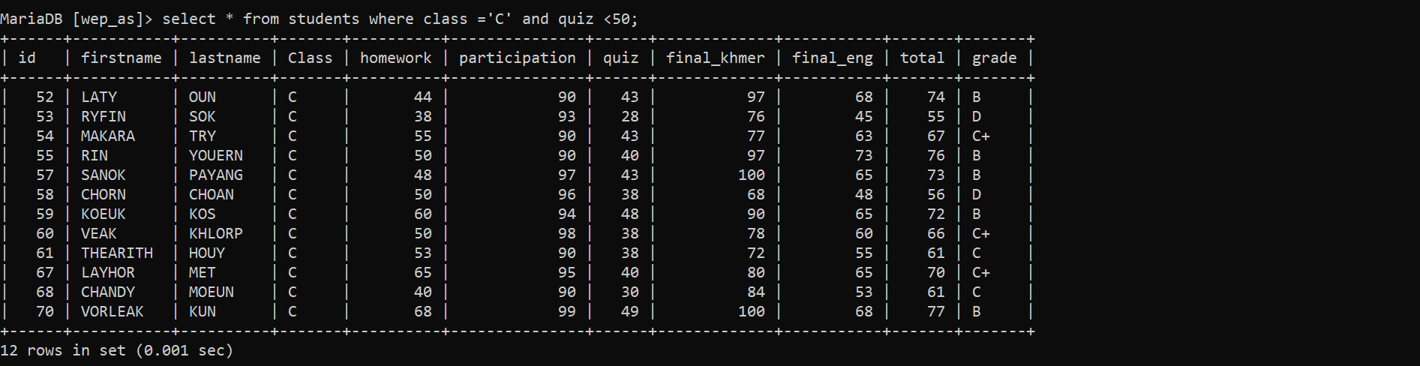

1. Get all students who need to do make up exam all class

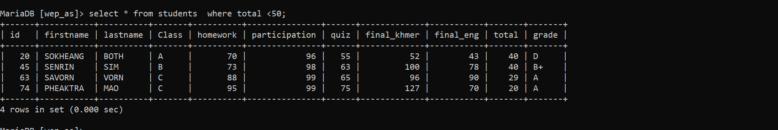

1. Get all students who get total score between 80 – 100

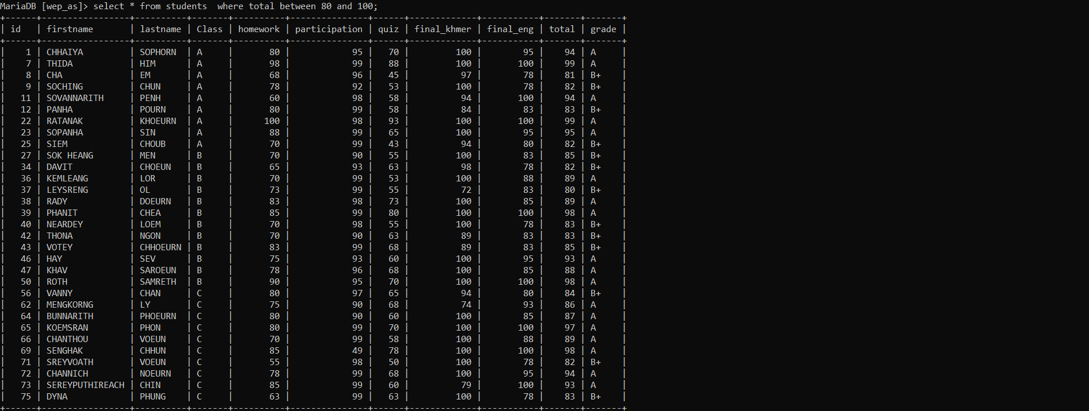

1. Get all students who have last name finished with letter “**N**”

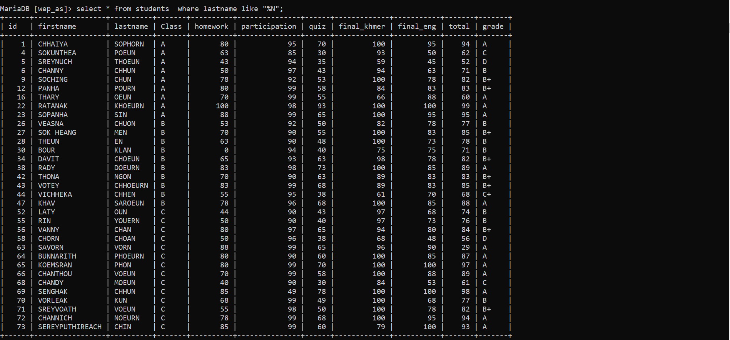

1. Get all students who have first name start with letter “**S**”

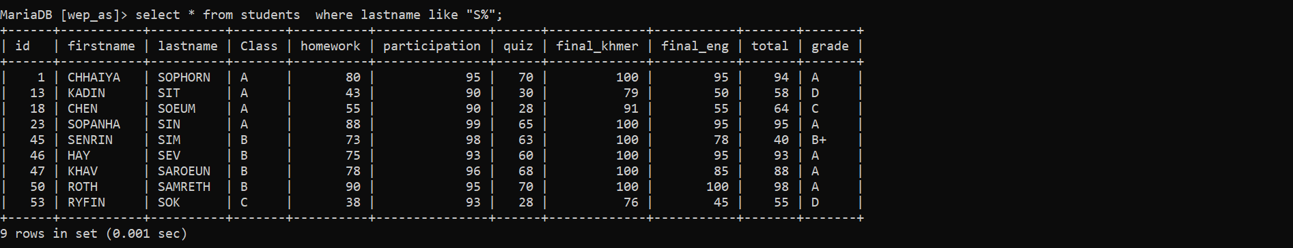

1. Get only students who has grade A from class B display only first name, last name and grade

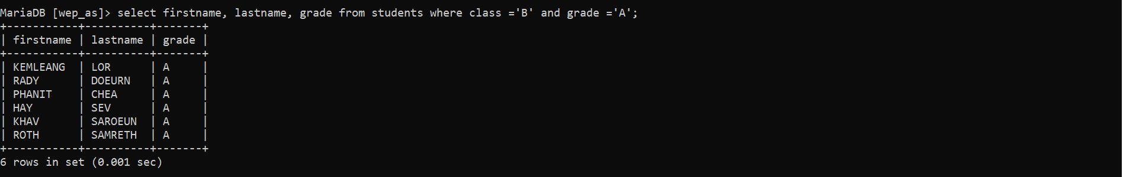

1. Sum all score for Vorleak

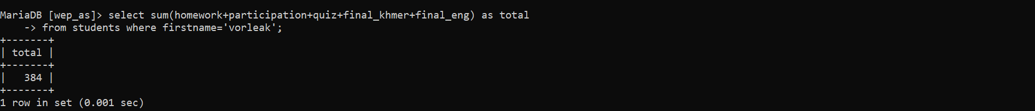

1. Update Pheaktra and Sanok from class C to class B



1. How many students get grade A?

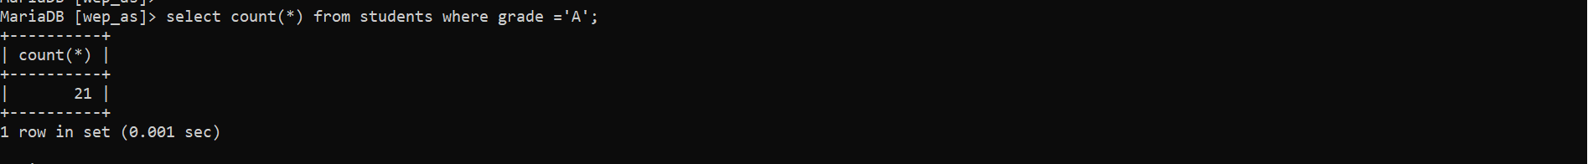

1. Delete all students who failed quiz



1. Merge first name and last name to one column

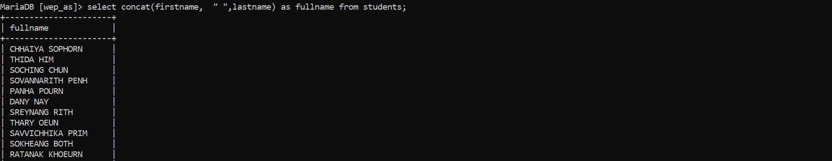

1. Get first 10 students from the list

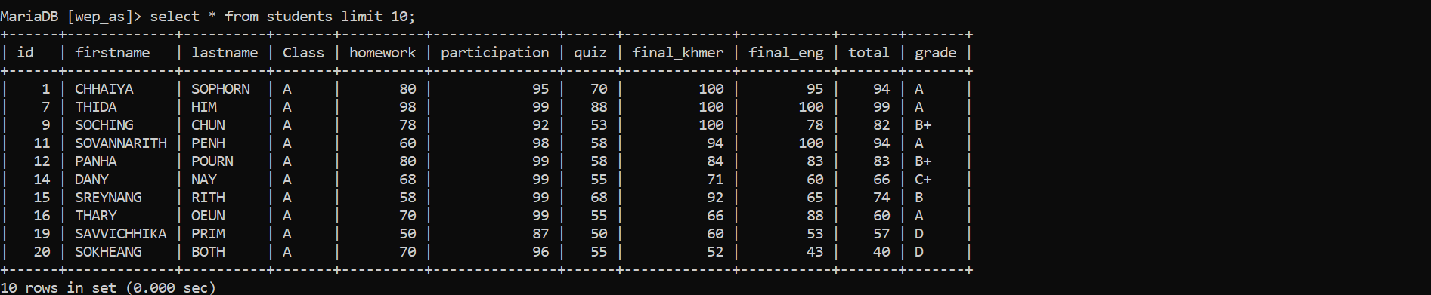

1. Get average total score from the list

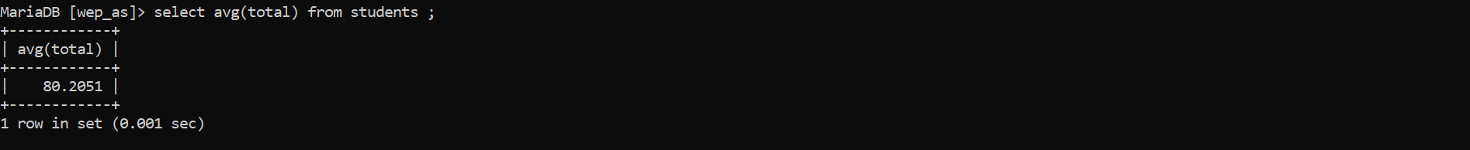

1. Get all who have total score less than average score of the list

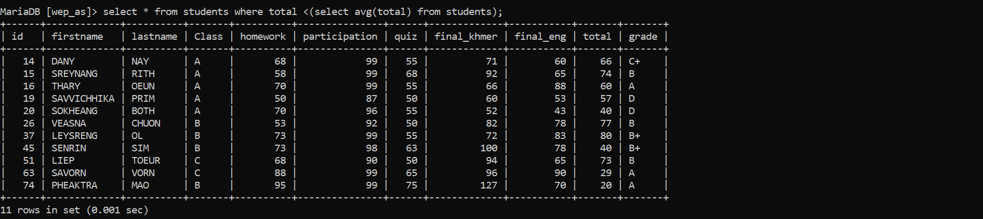

1. Get all who have total score equal maximum score in the list

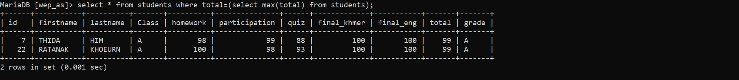

1. Get all who have quiz score equal minimum score quiz in the list

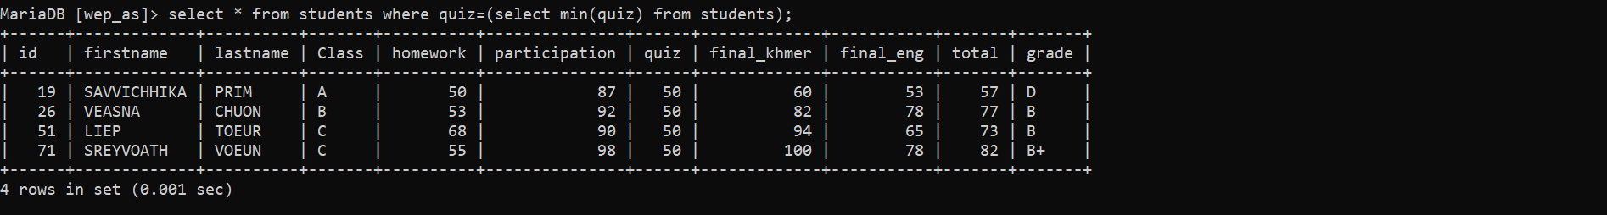

1. Get all students who have maximum score equal total and quiz score less than average quiz score



1. Get all students order by last name desc (ASC: A-Z , DESC : Z-A)

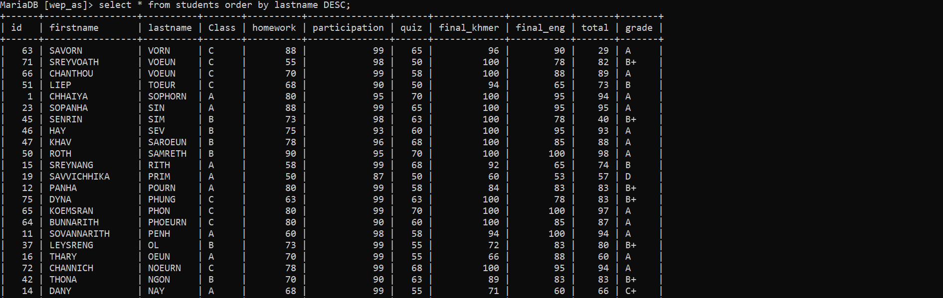

1. Get unique grade from table

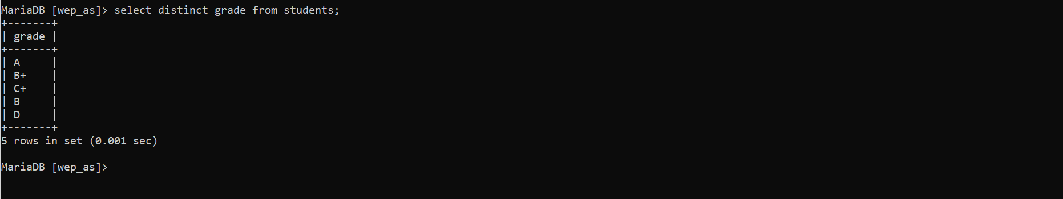

1. Get first name , last name of students and group by class

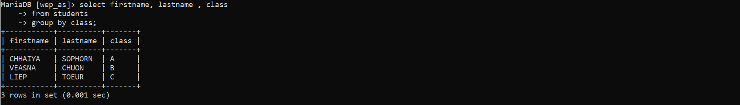

1. Get full name , homework , quiz, total



1. Delete who has first name start with letter “C”

